The Inaja Forest Fire Disaster
(Pronounced Inn•ah•HAH)

November 25, 1956
Cleveland National Forest, California Region

Origin of Fire
The Inaja Fire allegedly was set by a 16-year-old Indian, Gilbert Paipa, at his home on the Inaja Indian Reservation about 9:10 a.m., Saturday, November 24, 1956. He was apprehended by, and confessed to, Forest Service Investigator Elwood Stone, on Wednesday, November 28. Paipa said, “I just got a mad, crazy idea to do it. I threw a match in the grass to see if it would burn.”

Initial Control Action
Two lookouts ^{[1]} reported the fire at 9:15 a.m. A three-man tanker crew arrived at 9:25. They could not control it. Acting Ranger John Davis recognized the fire’s danger and dispatched additional men and equipment. By 5:00 p.m., the fire had crossed the San Diego River bed to the west, run over Mt. Gower and down the west side of El Capitan Reservoir and onto El Cajon Mountain. It had then burned and estimated 25,000 acres. In a meeting attended by Forest Supervisor Walter Puhn and officials of the California Division of Forestry, it was agreed that the State would handle all the fire west of the San Diego River except a portion on the north side of the fire between the river and Sawday truck trail. This latter division was across the river from Division IV, where the tragedy later occurred.
¹ This and other technical terms in this report are explained in a glossary on the last page.
On the second day of the fire, the Forest Service had four fire fighting divisions led by experienced and qualified personnel from all parts of the California Region. Pine Hills Guard Station was fire headquarters. The flanks of the fire had been contained except for three hot sectors -- a hand line from Eagle Peak down to the San Diego River on the south; across San Diego Canyon from rim to rim on the north; and across Cedar Creek at the rear of the fire. The latter was considered of greatest concern due to the threat to more than 100 homes nearby.
During the day, Sunday, the fire in San Diego River Canyon was advancing slowly up the canyon against the wind with occasional flare-ups. Tongues of flame intermittently moved ahead and up small side ridges. Fire on and just below the east rim of the canyon was quartering into the wind with occasional flare-ups as it reached heavy fuels.
High winds made it impossible to use helicopters until 4:00 p.m. The night line boss scouted Division IV on the north side and east of the San Diego River at 4:30 p.m. (An aerial photo-map of this area is shown on page 3.) Because of the wind, he had to fly high. This situation, coupled with the smoke from the fire, made it impossible for him to get complete information as to control lines lost and progress of construction of other lines. The fire edge was relatively hot, burning into the wind on the west side and more slowly on the east side.

Burning Conditions
Fire weather throughout southern California in 1956 was unusually severe. It was climaxed by a prolonged period of Santa Ana wind conditions ^{[2]} extending from November 19 through the Inaja fire disaster on November 25. The area was having unprecedented drought. Rainfall had been well below normal for 4 years.
² Strong, dry winds from the desert area east of the coast mountains flowing down through the mountain passes and canyons to the sea.
During the afternoon and evening of November 25, relative humidity in the vicinity of the fire was near 18 percent and the temperature was about 68°F. Gusty east and northeast winds averaging 15 or 20 miles per hour, but with some gust up to 40 miles, were observed at many places around the fire.
Brush consisting of chamise and sagebrush of medium density covered much of the disaster area. Moisture content of the brush approximated the lowest ever measured for these species, and is believed to be near the minimum possible.
The San Diego River bed was dry. The canyon walls are steep and rugged, with slopes as steep as 70 percent in many places. Rock outcroppings are common on both sides of the canyon. The distance from the rim to the river bed was about 3,500 feet in the disaster area.

Day Shift Action, November 25
The job to be done on the east side of the San Diego River Canyon (Division IV, Sector G) was to clear by tractor a fire trail through the brush along the rim of the canyon and to construct by hand a similar trail from the top of the canyon rim to the dry river bed on the canyon floor. These trails were to serve as control lines for burning back to the main fire.
The tractor-built trail running along the rim was completed by 11:00a.m. Some burning out to make the trail wider was started. The trail was patrolled by a 4-man crew, using a 280-gallon water tanker. Two attempts were made to start hand construction of the trail from the top of the rim to the canyon floor. In both cases the men were called back when it became evident that trail could not be completed before being flanked by the main fire. Later in the day a third line was started. By 2:00 p.m. the crew had cut about 600 feet of fire trail downward from the canyon rim. It was estimated that 3 more hours of work were needed to reach the bottom. At about 3:00 p.m. the division boss withdrew the men from the third line because fire conditions seemed to make the work there unsafe. The crew had completed nearly 1,100 feet of trail. The crew continued to patrol the tractor-built trail along the top rim of the canyon. Between 4:30 p.m. and 7:00 p.m. the fire quieted down. No flare-ups were observed during this period.

Night Shift Action, November 25
At the main camp the night shift division boss was instructed to build line and burn out. since there was little specific information on Sector G available at the main camp because of partial ineffectiveness of aerial reconnaissance, he was told to check with the day division boss for conditions on the ground.
The night shift arrived at the fire after dark, about 7:00 p.m. The day division boss briefed the night division boss on fire conditions and work done during the day. He emphasized that during the day the wind had been tricky and that difficulty had been experienced along the rim when burning-out operations were attempted. The night division boss discussed the conditions with his two sector bosses, and they agreed upon a plan of action. One sector boss and one crew boss with 20 inmates were to burn out along the tractor-built line on the canyon rim and down the hand line. Operations of this kind are normally carried out at night when winds subside and burning conditions are less hazardous.
The second sector boss with 3 crew bosses, the correctional officer, and 13 inmates was to complete the cutting and scrapping of the hand trail to the river. The two sector bosses synchronized their watches at 7:18 p.m. and agreed to have a radio check at 7:55 p.m.
The plan went into operation with men going down the hand line and the tanker crew on the rim laying a hose to help hold the burning-out fire. One length of hose broke and some water was lost in replacing it. The water in the tanker was used up by 8:00 p.m.
The brush cutters in the 13-man trail-building crew started work as soon as they reached the point where the day crew had stopped work. The scrapers waited a few minutes until the cutters got a short piece of trail cleared. The boss of these scrapers lined out his men and gave them instructions on the work they were to do. He then went back up the fire trail toward the canyon rim to check on the burning-out work as the sector boss had previously instructed him to do.
When the scraper crew boss go the top of a small 15-foot bluff on the trail, approximately 75 feet in a direct line from the canyon rim, he noticed a that the main fire was unexpectedly flaring up on a side ridge more than 1,000 feet below the men. Suddenly it made a short run toward the main ridge where the men were building trail. He called a warning to the men working on the fire trail below and told them to come out. One of the bosses below answered his warning.
The men stopped work and all started back up the trail at a normal pace. This was at about 7:45 p.m. The men farthest down the hill had approximately 1,100 feet to travel up the trail. Survivors reported that there was no panic. Some of the men wondered why they were being called out. Most of them kept their tools. One even picked up a shovel and canteen abandoned by another.
The fire below suddenly gathered momentum and the crew boss on the top of the small bluff saw that it was now a real threat to the men below. This happened about 2 minutes after the first warning and he again yelled to the men, telling them to hurry up. Most of the men now dropped their tools and began to go faster.
Two of the men stationed on the upper part of the line escaped before the fire reached the rim. Two others who also had been working on the upper part of the line stopped at a small open spot just below the rock bluff on the cleared line. Others pressed on up to them from below. Within a minute or two, 5 men who had been working lower on the line reached the 2 men waiting in the open spot. They were slightly ahead of the remaining 9 men. By this time the fire had outrun them to the right and had crossed the cleared trail above. These 5 men turned off to the left, climbed and struggled up the 15-foot rock bluff, and raced the remaining 75 feet to safety at 8:05 p.m. They reported later that on this last stretch the fire was only 10 feet behind them.
The eleven victims were cut off while still below the small bluff, presumably by an instantaneous “flash-over” of a large area of fire. This sudden expansion of the fire front was testified to by the survivors and other nearby observers. In addition, two fire bosses on the opposite side of the main San Diego Canyon observed the action of the fire when it made its fatal run. They reported that it ran up the ravine beside the ridge where the men were working and across the fire trail near the top. At about the time the fire got to the rim there was a sudden “flash-over” to the left, which the observers said simultaneously ignited a large area, perhaps 40 acres. This explosive “flash-over” enveloped the 11 victims just below the small bluff. It apparently was caused by ignition of gases forced up the ravine by the extremely rapid run of the fire.
All victims were found in an area with a radius of 45 feet and the lowermost one was only 300 feet from the tractor-built line at the top of the canyon rim. The fire barely crossed this line in only a few places, where it was quickly put out. Of the men that escaped, two had been working at the very lowest part of the trail. Two who had been working closest to the rim did not escape.
Several of the fire fighters, including the forest officers who lost their lives, stayed with the crew until the last, helping and urging others out even though they might otherwise have had an opportunity to escape. One of those who escaped credited a fellow crew man with saving his life when he became exhausted while climbing over the rock bluff.

Control of the Fire
Before being controlled at 6:00 p.m., Wednesday, November 28, the fire burned 43,611 acres within the Cleveland National Forest and adjoining land protected by the State. The area burned had a 90 mile perimeter. At least 5 homes were destroyed. More than 2,000 men fought the fire, 1,300 under Forest Service supervision. These included 500 Indians (local and Southwestern Region), about 500 Navy personnel, 200 inmates from San Diego County and State Honor Camps, and other organized crews. These men plus 3 helicopters, 4 air tanker planes, 2 scouting planes, 27 bulldozers, and a fleet of 90 stake, tank, and pickup trucks, formed one of the greatest arrays of men and equipment ever assembled to fight a forest fire in San Diego County.

Conclusions
- Fire Behavior. The disastrous flareup of the Inaja fire was caused by a critical combination of highly flammable fuels, steep topography, and adverse weather. The lull in the fire before and at the time of arrival of the night crews created a false sense of security, even though existing conditions of fuel, topography, and weather were critical.
- Crew location in canyon. The men were taken down the line into the canyon owing to a lack of information to show possible danger from the fire in the canyon below. The contributing factors were:
  - Absence of specific information on the fire status in San Diego Canyon available for the briefing at the base camp, due to poor conditions for aerial reconnaissance.
  - Emphasis placed on the danger of the burning-out fire rather than on the main fire in the canyon below, when the day division boss briefed the night overhead personnel.
  - Quiet appearance of the fire as viewed from the rim.
  - The night overhead personnel had not seen the terrain in daylight.
  - Lack of detailed scouting of the canyon on sector G during the day.
  - Absence of contact with the bosses of the division across the canyon who had a different vantage point for viewing the situation.
- Trail location. The location of the fire trail on the specific ridge where it was built instead of the spur ridge up the canyon was questionable. The previous behavior of the fire and the position above and alongside a precipitous chimney made the chosen location hazardous.
- Burning-out. Sound fire fighting principles call for burning out the intervening fuels between the control line and the fire edge. The effect of the burning-out fire on the behavior of the main fire and of the planned escape routes is a vital factor influencing decisions on when, where, and how to burn out, and where to place men.
Fire behavior is not well enough understood to firmly establish the possible effect of the burning out fire in sucking the main fire rapidly up the chimney at the site of the disaster. Other factors would have permitted the explosive run without the presence of the burning-out fire. Furthermore, the burning-out fire did not cut off the escape route.
- Lookout. The crew cutting line into the canyon received warning to come out when a crew boss on the upper part of the line saw the fire heating up at a point below the men. It is uncertain in the Inaja fire disaster that a specifically designated lookout would have given warning any sooner. However, it is vital that a lookout be designated when crews are in a potentially dangerous location.
- Water. Exhausting the water supply from the tanker at the time of the flareup did not cause or contribute to the tragedy. the flames that raced up the canyon slope were of such height and were extended so far in advance of the burning fuel, that water available from one or several ground tankers would not have had a material effect.
- Personnel. The leaders on the Inaja fire were capable and experienced. They were trained in accordance with recognized Forest Service standards. There is, however, need for more intensive fire behavior training for key fire supervisory personnel.
Line crews on the sector where the tragedy occurred were experienced, trained fire fighters. Moreover, on this sector there were experienced overhead personnel from the local forest and from other forests.

Recommendations of the Investigating Team
- It was strongly brought out by the investigation that better knowledge of fire behavior must be developed as an essential means of preventing future fire tragedies. Research studies even more comprehensive and penetrating than past and current fire behavior research must be carried out to determine means of fighting mass fires and the behavior of fires in forested areas, especially in rough topography. In addition to progress in fire control methods already made, new and more powerful methods of attacking mass fires are needed and must be developed. Such methods, like use of aerial attack with water and chemicals, may provide the means of controlling dangerous fires with less risk to human lives.
- More experts on fire behavior must be developed for assignment to critical fires. These highly skilled experts would evaluate situations and assist fire bosses in making decisions for safe, effective fire fighting.
- The investigators pointed out that in general, although not related in particular to the Inaja fire, present Government salary and wage rates make it difficult to obtain and hold competent fire control personnel. Controlling mass forest fires is a difficult and highly technical job. The specifications for these positions should be further reviewed with appropriate Department and Civil Service Commission officials.

Working Notes and Data
The investigating team’s voluminous notes, maps, photographs, analyses of weather records, fuel moisture measurements, fire behavior observations, information on training and experience of leaders, etc., are to be filed with the office copy of this report. Further study will be made of this material and a Service memorandum will be prepared covering points which may be helpful to Forest Service officials having fire control responsibilities.

Glossary
Base camp.--Same as main camp, in this case. See Main camp.
Control line.--See Hand line.
Division.--A unit of a complex fire perimeter between designated topographical or cultural features (such as ridges, streams, and roads) organized into two or more sectors for control.
Fire trail.--Same as fireline. See Hand line.
Fire weather.--Weather factors that affect the probability that forest fires will start and their rate of spread after starting. It is the composite of elements such as drought conditions, wind, and air temperature and relative humidity.
Flanks of a fire.--The parts of a fire’s perimeter that are roughly parallel to the main direction of its spread or progress.
Hand line.--A fireline or control line made with hand tools rather than machines such as bulldozers. A strip a few inches to several feet wide is scraped or dug to mineral soil so that fuel is absent and the fire’s progress may be halted when it reaches the fireline. Sometimes a fireline is located some distance from the main fire and then the intervening vegetation and fuels are purposely burned to make a much wider strip devoid of fuel. This is called backfiring or burning out.
Lookout.--A person designated to detect and report forest fires, from a vantage point such as a tower or a natural elevation.
Main camp.--Headquarters of a the fire boss, who is responsible for all suppression and service activities at a fire. Same as fire headquarters.
Sector.--A designated segment of fire perimeter or control line comprising the suppression work unit for two or more crews under one sector boss.
Tanker.--A truck equipped to carry water or other liquids used in suppressing a fire.

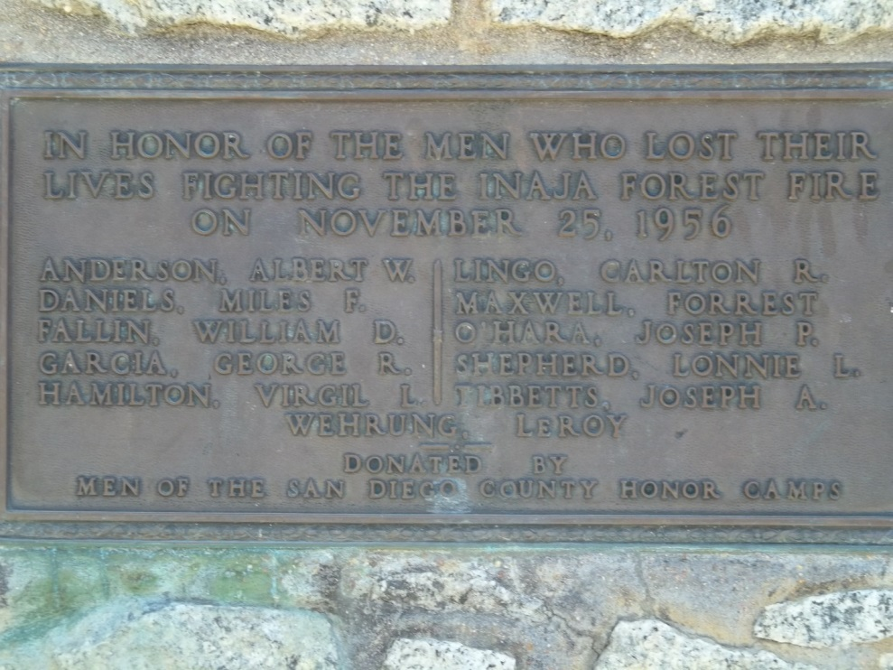
Inaja Memorial Plaque

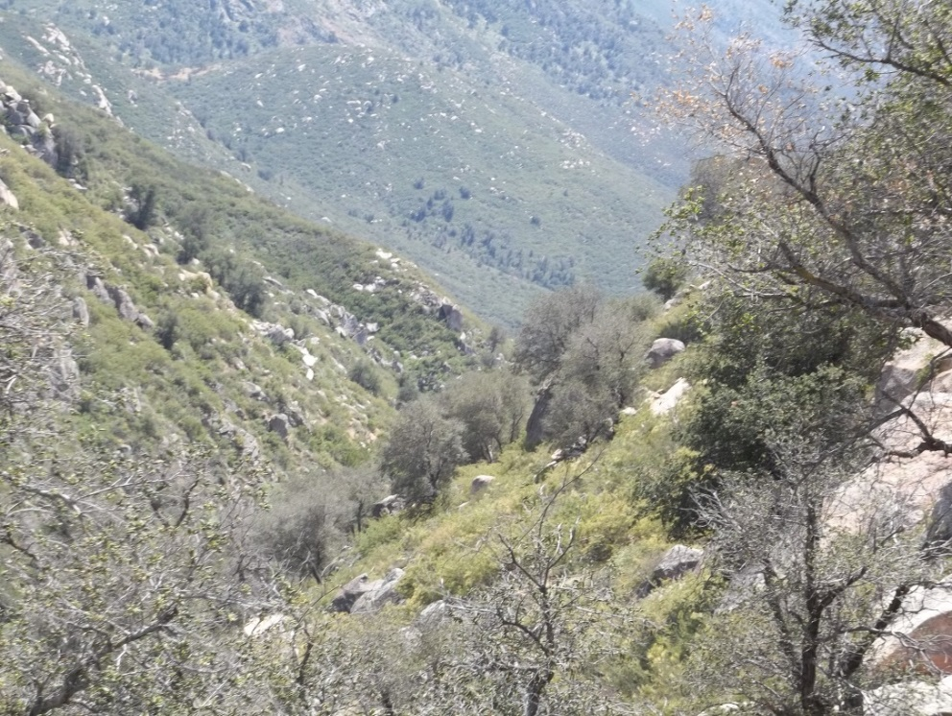

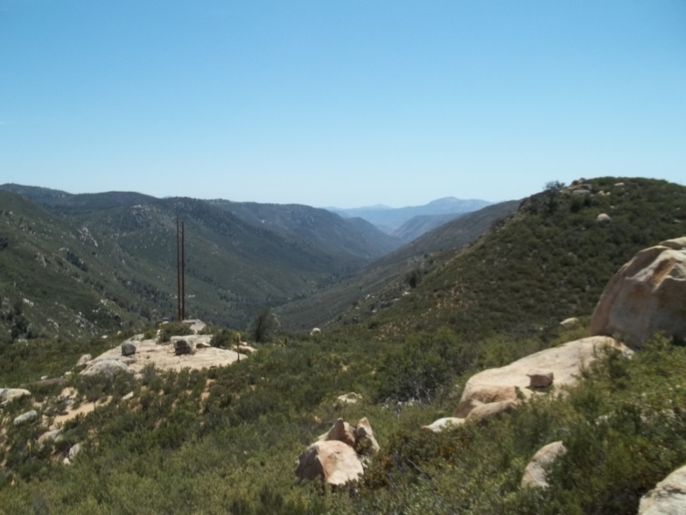
Both pictures are of the San Diego River Canyon looking south from the Inaja Memorial trail.
Questions:
1. What topographic features contributed to the Inaja Fire tragedy?
2. What fuel conditions contributed to the Inaja Fire tragedy?
3. What weather factors contributed to the Inaja Fire tragedy?
4. What suppression activities contributed to the Inaja Fire tragedy?
5. The “Downhill Fire Line Checklist” was created well after this fire. Look this up in either the Fireline Handbook or the IRPG. What items were and were not addressed on the checklist?

